Assessment: Lab Exam 2

Student Name: Zahi Masarwa

Lab Professor Name: Mel Sanschagrin

Lab Section Number: 303

Due Date: 04/13/21

# Pseudocode

Start

Declare final int update_Kitchen=303;

Declare final int report_Kitchen=304;

Declare final int quit_program=305;

Declare class InputUser input ;

Declare class KitchenSink kitchensink;

Declare int choice;

Do{

Output “303 to update kitchen sink”

Output “304 to view kitchen sink report”

Output “305 to quit program”

Output “Program by Zahi Masarwa”

Input choice;

Switch (choice)

Case update_Kitchen:

Output ” Enter manufacturer”

setManufacturer(input string)

Output “Enter material”

setMaterial(input string)

output “Enter capacity”

setCapacity(input double)

Case report_Kitchen:

Output(createReport())

Case quit_program:

Output “Program quits”

Default:

Output “Choice enterd is incorrect please enter again”

}while (choice!= quit_program)

End

Start UserInput;

Declare scanner;

Function double input Double

{

While input is not double

Scan next line

Print Number entered is not double please enter again

End while

Declare double result =new input

Return result

}

Function int inputInteger

{

While input is not integer

Scan next line

Print Number entered is not integer please enter again

End while

Declare int result =new input

Return result

}

Funcation string inputstring

{

Return input string;

}

End

# Screen shots of program execution

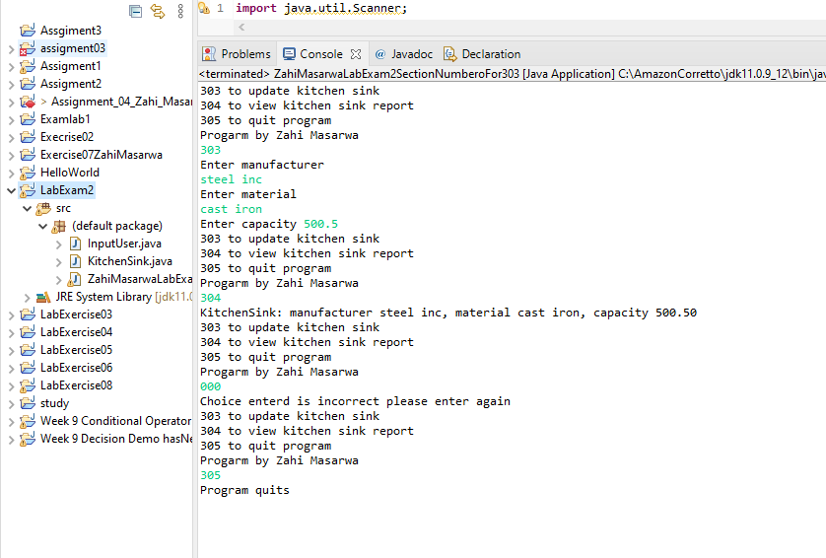

# Program code

**public** **class** ZahiMasarwaLabExam2SectionNumberoFor303 {

**public** **static** **void** main(String[] args) {

//declare constants

**final** **int** update_Kitchen=303;

**final** **int** report_Kitchen=304;

**final** **int** quit_program=305;

//declare class constructors

InputUser input=**new** InputUser();

KitchenSink kitchensink=**new** KitchenSink();

//declare the input choice

**int** choice;

//do while loop to run the program

**do** {

//outputs the options

System.***out***.println("303 to update kitchen sink");

System.***out***.println("304 to view kitchen sink report");

System.***out***.println("305 to quit program");

System.***out***.println("Program by Zahi Masarwa");

choice=input.inputInteger();

//switch to lay the option

**switch** (choice) {

**case** update_Kitchen:

System.***out***.println("Enter manufacturer");

kitchensink.setManufacturer(input.inputText());//input manufacturer

System.***out***.println("Enter material");

kitchensink.setMaterial(input.inputText());//input material

System.***out***.print("Enter capacity");

kitchensink.setCapacity(input.inputDouble());//input capacity

**break**;

**case** report_Kitchen:

System.***out***.println(kitchensink.createReport());//output report

**break**;

**case** quit_program:

System.***out***.println("Program quits");//output program quits

**break**;

**default**:

System.***out***.println("Choice enterd is incorrect please enter again");

**break**;

}

} **while** (choice!=quit_program);//Condition when to quit the program

}

}

**import** java.util.Scanner;

**public** **class** InputUser {

**private** Scanner scanner = **new** Scanner(System.***in***);

//method input double

**public** **double** inputDouble() {

**while**(!scanner.hasNextDouble()) {

scanner.nextLine(); // clean up the input stream

System.***out***.println("Number entered is not double please enter again");

}

**double** result= scanner.nextDouble();

scanner.nextLine(); // clean up the input stream

**return** result;

}

//method to input integer

**public** **int** inputInteger() {

**while**(!scanner.hasNextInt()) {

scanner.nextLine(); // clean up the input stream

System.***out***.println("Number entered is not integer please enter again");

}

**int** result = scanner.nextInt();

scanner.nextLine(); // clean up the input stream

**return** result;

}

**public** String inputText() {

**return** scanner.nextLine();

}

}

# Code Screen Shoots

